Quarterly Report – Public Page

Date of Report: 2nd Quarterly Report, March 21, 2024
Contract Number: 693JK32310013POTA
Prepared for: Government Agency: DOT and Co-funders
Project Title: Tank Foundation and Floor Designs and Best Practices for Improved Corrosion Control
Prepared by: Pipeline Research Council International (PRCI), Inc.
Contact Information: Janie Norton, jnorton@prci.org 703-205-1600 ext: 105
For quarterly period ending: March 31, 2024

1: Items Completed During this Quarterly Period:
Item # | Task # | Activity/Deliverable | Title | Federal Cost | Cost Share
4 | 2 | 2nd quarterly status report & project management | Submit 2nd quarterly report | $14,701 | $3,675

A subcontract with Mears Group, Inc has been completed. Kickoff meeting was held February 7th. Started Task 1 Literature Review and Evaluation of Industry Practice. Created framework for data mining meetings.

2: Items Not-Completed During this Quarterly Period:
Item # | Task # | Activity/Deliverable | Title | Federal Cost | Cost Share
1 | 1 | Kick-off web meeting with all stakeholders | Meeting minutes and a Summary of the Literature Review to be included in the  quarterly report | $34,863 | $8,716
3 | 2 | Facilitated Meetings/Data Mining of Operator-Industry Tank Designs, Corrosion Prevention, Monitoring and Leak Detection. | Summary of the industry tank designs and corrosion prevention and Leak detection and Release Prevention performance will be included in the quarterly report | $68,277 | $17,069

The project is behind schedule currently due to contracting at start of project but will catch up in coming quarters.

3: Project Financial Tracking During this Quarterly Period:
Note that this chart reflects Federal share only:
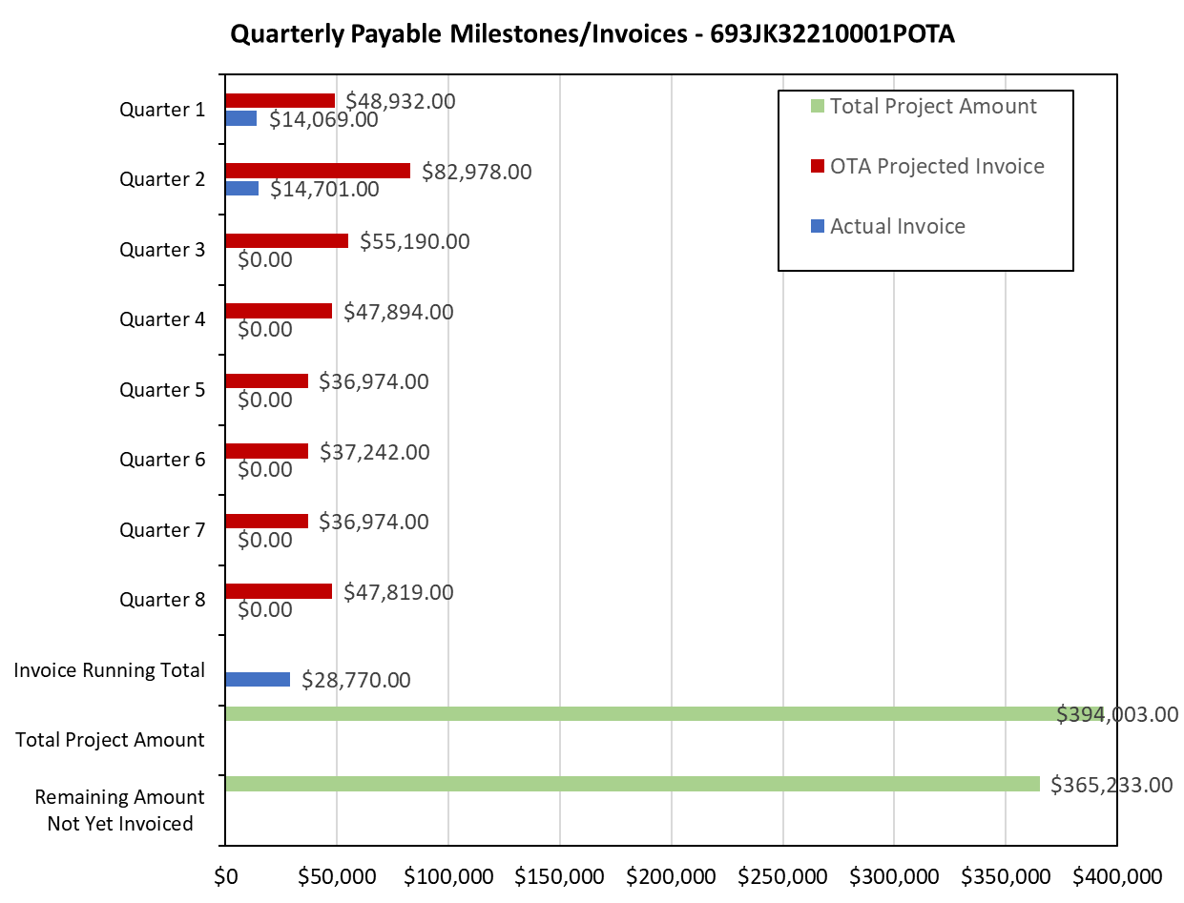

4: Project Technical Status –
Kickoff meeting was held February 7th. Started Task 1 Literature Review and Evaluation of Industry Practice. Created framework for data mining meetings.

5: Project Schedule –
The project is behind schedule.

